**Creating Fields For Detailsofcustomers Object**

**Creating Fields for Detailsofcustomers object:**

1)While still on your salesforce account, navigate to the gear icon present in the top right corner. You will notice Setup and click on setup.

2)You will now be navigated to the setup page, and click on object manager and search for object “Detailsofcustomer”.

3)Click on “Fields & Relationships” in the left panel.

4) Click on New and choose the data type ( that is required by the field you need.

5) Click next and fill the following details in the mentioned.

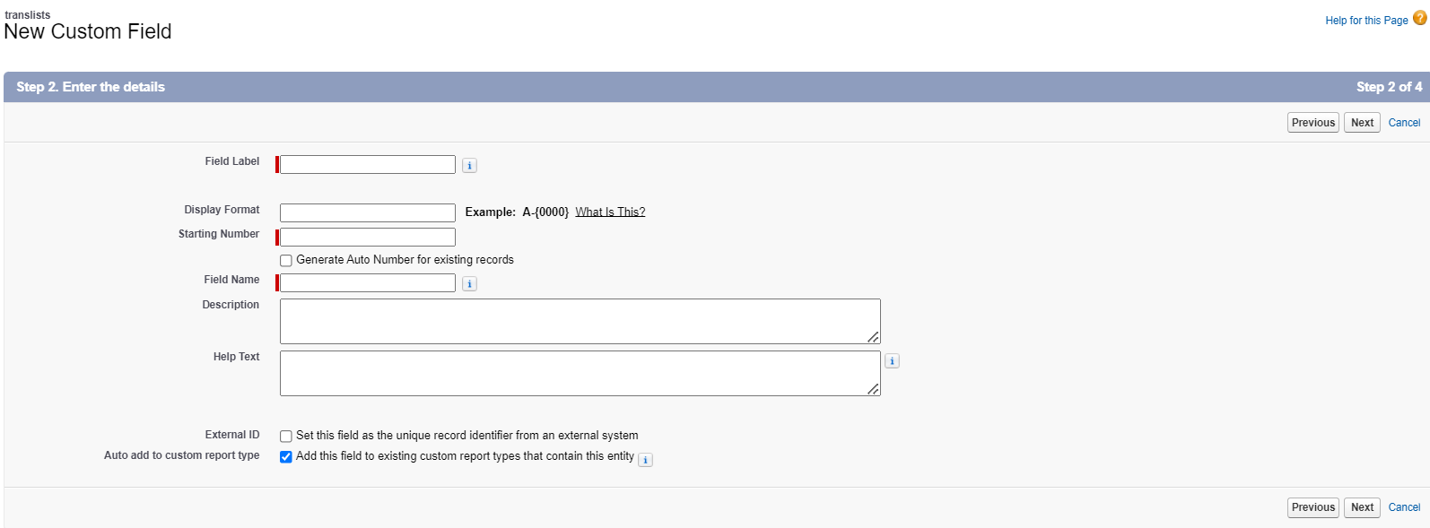6) Click Next, Next and click on “Save and New”.

**Note :** Similarly create the fields contno, detailsofcustomer name, mailid and tid.

|  |  |  |
| --- | --- | --- |
| **S No** | **Field Label** | **Data Type** |
| 1 | Detailsofcustomer name | Text(80) |
| 2 | mailid | Email |
| 3 | Contno | Phone |